Unit 2
Goal-based agent called a problem-solving agent. Problem-solving agents use atomic representations, that is, states of the world are considered as wholes, with no internal structure visible to the problem solving algorithms. Goal-based agents that use more advanced factored or structured representations are usually called planning agents.
2.1 Problem solving agents
- Intelligent agents are supposed to maximize their performance measure.
- Imagine an agent in the city of Arad, Romania, enjoying a touring holiday.
- Now, suppose the agent has a nonrefundable ticket to fly out of Bucharest the following day. In that case, it makes sense for the agent to adopt the goal of getting to Bucharest. Courses of action that don’t reach Bucharest on time can be rejected without further consideration and the agent’s decision problem is greatly simplified.
- Goals help organize behavior by limiting the objectives that the agent is trying to achieve and hence the actions it needs to consider. Goal formulation, based on the current situation and the agent’s performance measure, is the first step in problem solving.
- We will consider a goal to be a set of world states—exactly those states in which the goal is satisfied.
- The agent’s task is to find out how to act, now and in the future, so that it reaches a goal state.
- Before it can do this, it needs to decide (or we need to decide on its behalf) what sorts of actions and states it should consider.
- If it were to consider actions at the level of “move the left foot forward an inch” or “turn the steering wheel one degree left,” the agent would probably never find its way out of the parking lot, let alone to Bucharest, because at that level of detail there is too much uncertainty in the world and there would be too many steps in a solution.
- Problem formulation is the process of deciding what actions and states to consider, given a goal.
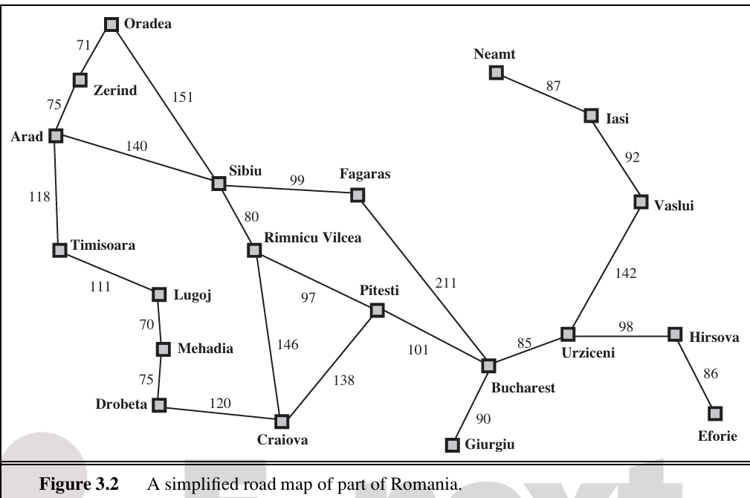
- Our agent has now adopted the goal of driving to Bucharest and is considering where to go from Arad. Three roads lead out of Arad, one toward Sibiu, one to Timisoara, and one to Zerind. None of these achieves the goal, so unless the agent is familiar with the geography of Romania, it will not know which road to follow.1 In other words, the agent will not know which of its possible actions is best, because it does not yet know enough about the state that results from taking each action. If the agent has no additional information—then it is has no choice but to try one of the actions at random.
- But suppose the agent has a map of Romania.
- The point of a map is to provide the agent with information about the states it might get itself into and the actions it can take.
- The agent can use this information to consider subsequent stages of a hypothetical journey via each of the three towns, trying to find a journey that eventually gets to Bucharest. Once it has found a path on the map from Arad to Bucharest, it can achieve its goal by carrying out the driving actions that correspond to the legs of the journey. In general, an agent with several immediate options of unknown value can decide what to do by first examining future actions that eventually lead to states of known value.
- We assume that the environment is observable, so the agent always knows the current state.
- For the agent driving in Romania, it’s reasonable to suppose that each city on the map has a sign indicating its presence to arriving drivers. We also assume the environment is discrete, so at any given state there are only finitely many actions to choose from. This is true for navigating in Romania because each city is connected to a small number of other cities. We will assume the environment is known, so the agent knows which states are reached by each action. (Having an accurate map suffices to meet this condition for navigation problems.) Finally, we assume that the environment is deterministic, so each action has exactly one outcome. Under ideal conditions, this is true for the agent in Romania—it means that if it chooses to drive from Arad to Sibiu, it does end up in Sibiu.
- The process of looking for a sequence of actions that reaches the goal is called search. A search algorithm takes a problem as input and returns a solution in the form of an action sequence. Once a solution is found, the actions it recommends can be carried out. This is called the execution phase. Thus, we have a simple “formulate, search, execute” design for the agent.
- After formulating a goal and a problem to solve, the agent calls a search procedure to solve it. It then uses the solution to guide its actions, doing whatever the solution recommends as the next thing to do—typically, the first action of the sequence—and then removing that step from the sequence. Once the solution has been executed, the agent will formulate a new goal.

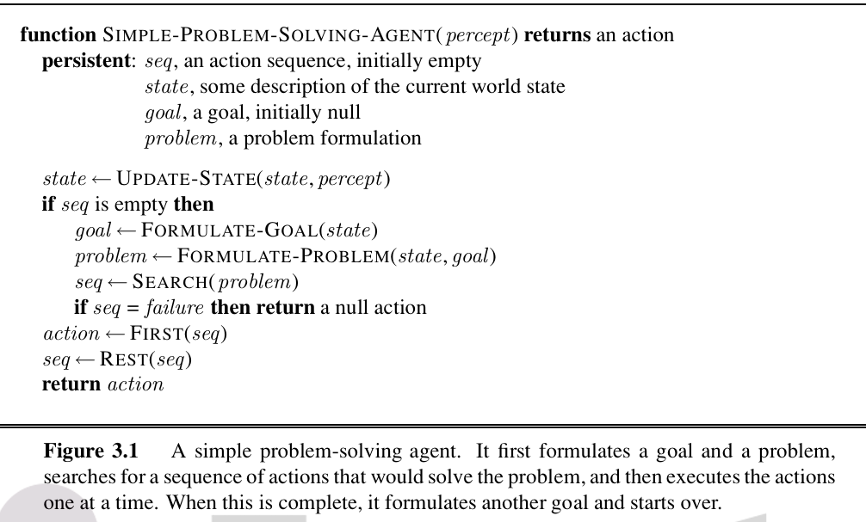
A problem can be defined formally by five components:
- The initial state that the agent starts in. For example, the initial state for our agent in Romania might be described as In(Arad).
- A description of the possible actions available to the agent. Given a particular state s, ACTIONS(s) returns the set of actions that can be executed in s. We say that each of these actions is applicable in s. For example, from the state In(Arad), the applicable actions are {Go(Sibiu),Go(Timisoara),Go(Zerind)}.
- A description of what each action does; the formal name for this is the transition model, specified by a function RESULT(s,a) that returns the state that results from doing action a in state s. We also use the term successor to refer to any state reachable from a given state by a single action. For example, we have (In(Arad),Go(Zerind)) = In(Zerind) .
- Together, the initial state, actions, and transition model implicitly define the state space of the problem—the set of all states reachable from the initial state by any sequence of actions. The state space forms a directed network or graph in which the nodes are states and the links between nodes are actions.A path in the state space is a sequence of states connected by a sequence of actions.
- The goal test, which determines whether a given state is a goal state. Sometimes there is an explicit set of possible goal states, and the test simply checks whether the given state is one of them. The agent’s goal in Romania is the singleton set {In(Bucharest)}.
- A path cost function that assigns a numeric cost to each path. The problem-solving agent chooses a cost function that reflects its own performance measure. For the agent trying to get to Bucharest, time is of the essence, so the cost of a path might be its length in kilometres. we assume that the cost of a path can be described as the sum of the costs of the individual actions along the path. The step cost of taking action a in state s to reach state s is denoted by c(s,a,s). The step costs for Romania as route distances. We assume that step costs are nonnegative.
The preceding elements define a problem and can be gathered into a single data structure that is given as input to a problem-solving algorithm. A solution to a problem is an action sequence that leads from the initial state to a goal state. Solution quality is measured by the path cost function, and an optimal solution has the lowest path cost among all solutions.
Formulating Problems:
A formulation of the problem of getting to Bucharest in terms of the initial state, actions, transition model, goal test, and path cost. This formulation seems reasonable, but it is still a model—an abstract mathematical description—and not the real thing. Compare the simple state description we have chosen, In(Arad), to an actual cross country trip, where the state of the world includes so many things: the traveling companions, the current radio program, the scenery out of the window, the proximity of law enforcement officers, the distance to the next rest stop, the condition of the road, the weather, and so on. All these considerations are left out of our state descriptions because they are irrelevant to the problem of finding a route to Bucharest. The process of removing detail from a representation is called abstraction.
2.2 Examples Problems
The problem-solving approach has been applied to a vast array of task environments. We list some of the best known here, distinguishing between toy and real-world problems. A toy problem is intended to illustrate or exercise various problem-solving methods. It can be given a concise, exact description and hence is usable by different researchers to compare the performance of algorithms. A real-world problem is one whose solutions people actually care about. Such problems tend not to have a single agreed-upon description, but we can give the general flavor of their formulations.
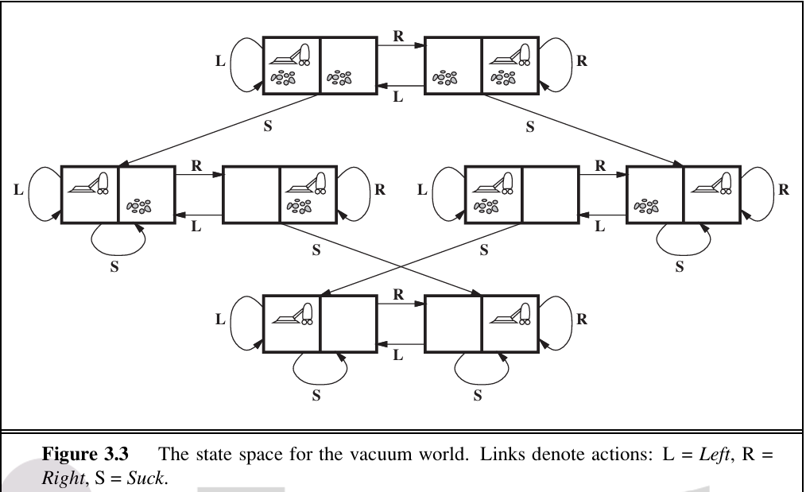
Toy Problems
- States: The state is determined by both the agent location and the dirt locations. The agent is in one of two locations, each of which might or might not contain dirt. Thus, there are 2 × 2² = 8 possible world states. A larger environment with n locations has n· 2^{n} states.
- Initial state: Any state can be designated as the initial state.
- Actions: In this simple environment, each state has just three actions: Left, Right, and Suck. Larger environments might also include Up and Down.
- Transition model: The actions have their expected effects, except that moving Left in the leftmost square, moving Right in the rightmost square, and Sucking in a clean square have no effect. The complete state space.
- Goal test: This checks whether all the squares are clean.
- Path cost: Each step costs 1, so the path cost is the number of steps in the path.

The 8-puzzle Problem
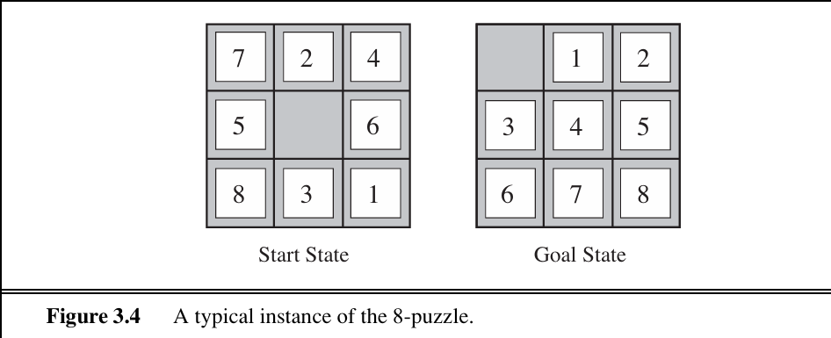
The 8-puzzle, consists of a 3×3 board with eight numbered tiles and a blank space. A tile adjacent to the blank space can slide into the space. The object is to reach a specified goal state, such as the one shown on the right of the figure. The standard formulation is as follows:
- States: A state description specifies the location of each of the eight tiles and the blank in one of the nine squares.
- Initial state: Any state can be designated as the initial state.
- Actions: The simplest formulation defines the actions as movements of the blank space Left, Right, Up,orDown. Different subsets of these are possible depending on where the blank is.
- Transition model: Given a state and action, this returns the resulting state; for example, if we apply Left to the start state in , the resulting state has the 5 and the blank switched.
- Goal test: This checks whether the state matches the goal configuration (Other goal configurations are possible.)
- Path cost: Each step costs 1, so the path cost is the number of steps in the path.
8-queens problem
The goal of the 8-queens problem is to place eight queens on a chessboard such that no queen attacks any other.
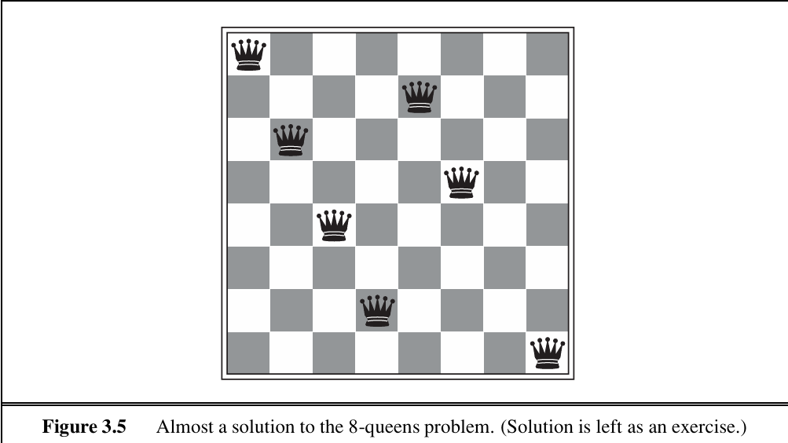
Although efficient special-purpose algorithms exist for this problem and for the whole n-queens family, it remains a useful test problem for search algorithms. There are two main kinds of formulation. An incremental formulation involves operators that augment the state description, starting with an empty state; for the 8-queens problem, this means that each action adds a queen to the state. A complete-state formulation starts with all 8 queens on the board and moves them around. In either case, the path cost is of no interest because only the final state counts. The first incremental formulation one might try is the following:
• States: Any arrangement of 0 to 8 queens on the board is a state.
• Initial state: No queens on the board.
• Actions: Add a queen to any empty square.
• Transition model: Returns the board with a queen added to the specified square.
• Goal test: 8 queens are on the board, none attacked.
In this formulation, we have 64 · 63···57 ≈ 1.8×1014 possible sequences to investigate. A better formulation would prohibit placing a queen in any square that is already attacked:
• States: All possible arrangements of n queens (0 ≤ n ≤ 8), one per column in the leftmost n columns, with no queen attacking another.
• Actions: Add a queen to any square in the leftmost empty column such that it is not attacked by any other queen.
Our final toy problem was devised by Donald Knuth (1964) and illustrates how infinite state spaces can arise. Knuth conjectured that, starting with the number 4, a sequence of fac torial, square root, and floor operations will reach any desired positive integer. For example, we can reach 5 from 4 as follows:
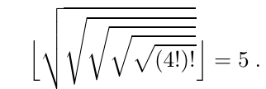
The problem definition is very simple:
• States: Positive numbers.
• Initial state: 4.
• Actions: Apply factorial, square root, or floor operation (factorial for integers only).
• Transition model: As given by the mathematical definitions of the operations.
• Goal test: State is the desired positive integer

2.3 Searching for Solutions
- A solution is an action sequence, so search algorithms work by considering various possible action sequences.
- The possible action sequences starting at the initial state form a search tree with the initial state at the root; the branches are actions and the nodes correspond to states in the state space of the problem.
- The first few steps in growing the search tree for finding a route from Arad to Bucharest. The root node of the tree corresponds to the initial state, In(Arad).
- The first step is to test whether this is a goal state. Then we need to consider taking various actions.
- We do this by expanding the current state; that is, applying each legal action to the current state, thereby generating a new set of states.
- In this case, we add three branches from the parent node In(Arad) leading to three new child nodes: In(Sibiu), In(Timisoara), and In(Zerind). Now we must choose which of these three possibilities to consider further.
- This is the essence of search—following up one option now and putting the others aside for later, in case the first choice does not lead to a solution.
- Suppose we choose Sibiu first. We check to see whether it is a goal state (it is not) and then expand it to get In(Arad), In(Fagaras), In(Oradea), and In(Rimnicu Vilcea).
- We can then choose any of these four or go back and choose Timisoara or Zerind.
- Each of these six nodes is a leaf node, that is, a node with no children in the tree.
- The set of all leaf nodes available for expansion at any given point is called the frontier.
- The process of expanding nodes on the frontier continues until either a solution is found or there are no more states to expand. Search algorithms all share this basic structure; they vary primarily according to how they choose which state to expand next—the so-called search strategy.
- Loopy paths are a special case of the more general concept of redundant paths, which exist whenever there is more than one way to get from one state to another. Consider the paths Arad–Sibiu (140 km long) and Arad–Zerind–Oradea–Sibiu (297 km long).
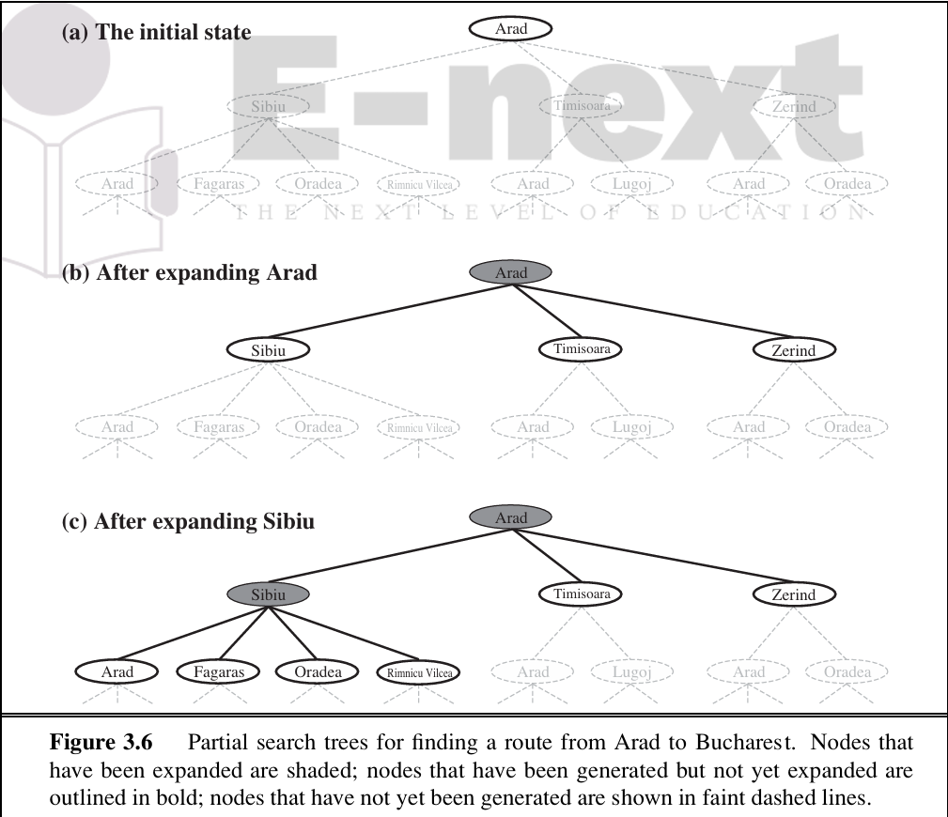
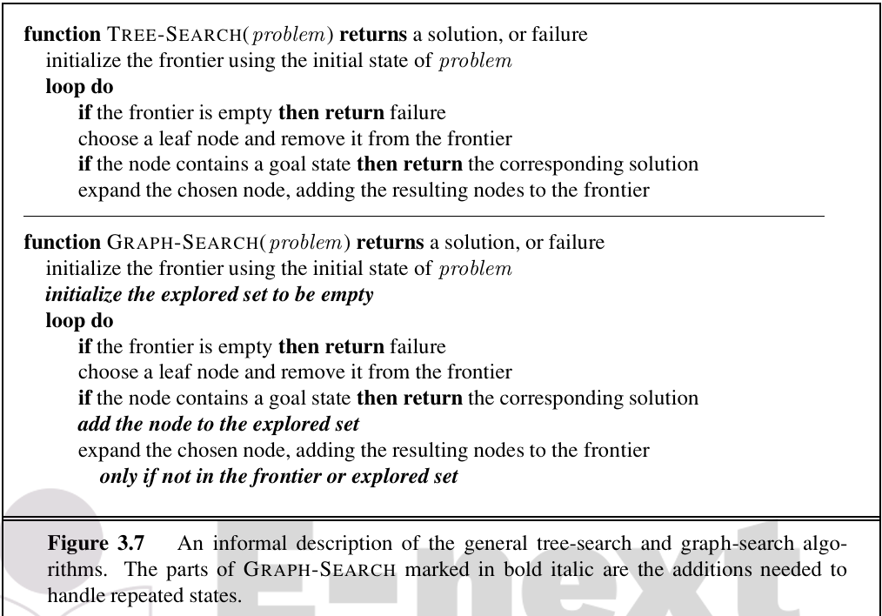
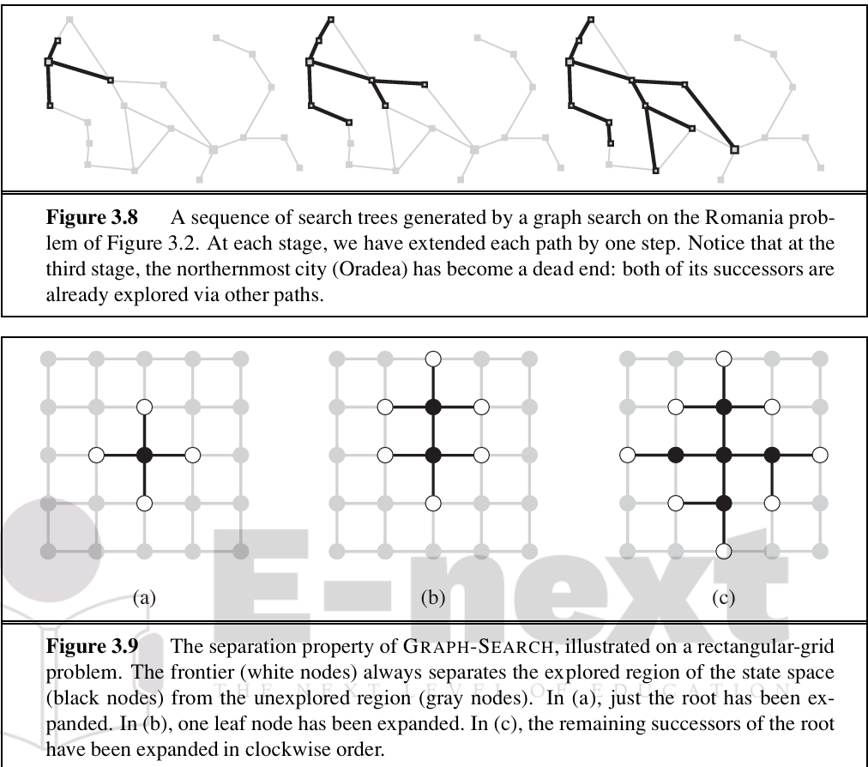
In other cases, redundant paths are unavoidable. This includes all problems where the actions are reversible, such as route-finding problems and sliding-block puzzles. Route finding on a rectangular grid is a particularly important example in computer games. In such a grid, each state has four successors, so a search tree of depth d that includes repeated states has 4^{d} leaves; but there are only about 2d² distinct states within d steps of any given state. For d =20, this means about a trillion nodes but only about 800 distinct states. Thus, following redundant paths can cause a tractable problem to become intractable. This is true even for algorithms that know how to avoid infinite loops.
Infrastructure for search algorithms
Search algorithms require a data structure to keep track of the search tree that is being constructed. For each node n of the tree, we have a structure that contains four components:
• n.STATE: the state in the state space to which the node corresponds;
• n.PARENT: the node in the search tree that generated this node;
• n.ACTION: the action that was applied to the parent to generate the node;
• n.PATH-COST: the cost, traditionally denoted by g(n), of the path from the initial state to the node, as indicated by the parent pointers.
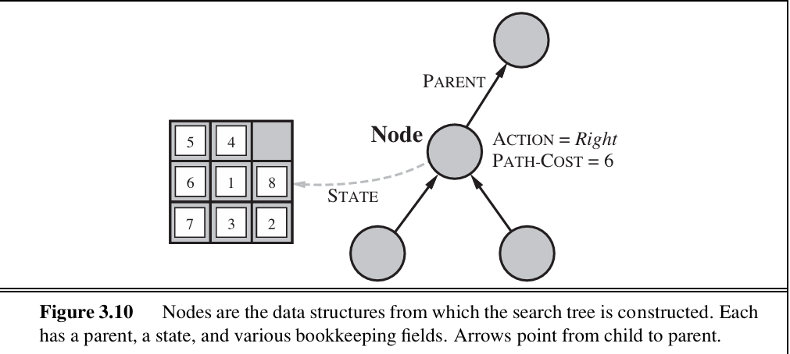
Given the components for a parent node, it is easy to see how to compute the necessary components for a child node. The function CHILD-NODE takes a parent node and an action and returns the resulting child node:
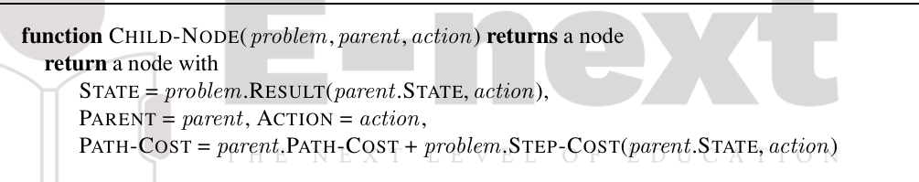

The frontier needs to be stored in such a way that the search algorithm can easily choose the next node to expand according to its preferred strategy. The appropriate data structure for this is a queue. The operations on a queue are as follows:
• EMPTY?(queue) returns true only if there are no more elements in the queue.
• POP(queue) removes the first element of the queue and returns it.
• INSERT(element, queue) inserts an element and returns the resulting queue.
Queues are characterized by the order in which they store the inserted nodes. Three common variants are the first-in, first-out or FIFO queue, which pops the oldest element of the queue; the last-in, first-out or LIFO queue (also known as a stack), which pops the newest element of the queue; and the priority queue, which pops the element of the queue with the highest priority according to some ordering function.

Measuring problem-solving performance
An algorithm’s performance in four ways:
• Completeness: Is the algorithm guaranteed to find a solution when there is one?
• Optimality: Does the strategy find the optimal solution, as defined on page 68?
• Time complexity: How long does it take to find a solution?
• Space complexity: How much memory is needed to perform the search?

2.4 uninformed search
The term means that the strategies have no additional information about states beyond that provided in the problem definition. All they can do is generate successors and distinguish a goal state from a non-goal state. All search strategies are distinguished by the order in which nodes are expanded. Strategies that know whether one non-goal state is “more promising” than another are called informed search or heuristic search strategies.
i) Breadth-First Search:
Breadth-first search is a simple strategy in which the root node is expanded first, then all the successors of the root node are expanded next, then their successors, and so on.
In general, all the nodes are expanded at a given depth in the search tree before any nodes at the next level are expanded.
Breadth-first search is an instance of the general graph-search algorithm in which the shallowest unexpanded node is chosen for expansion. This is achieved very simply by using a FIFO queue for the frontier. Thus, new nodes (which are always deeper than their parents) go to the back of the queue, and old nodes, which are shallower than the new nodes, get expanded first.
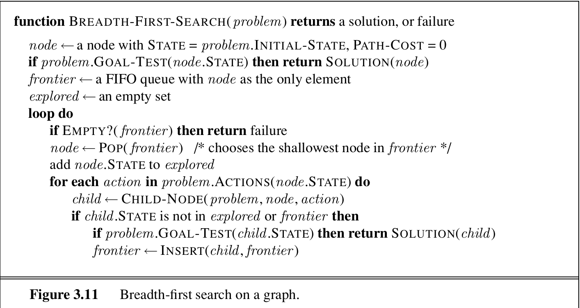
Breadth-first search is an instance of the general graph-search algorithm in which the shallowest unexpanded node is chosen for expansion. This is achieved very simply by using a FIFO queue for the frontier.
Thus, new nodes (which are always deeper than their parents) go to the back of the queue, and old nodes, which are shallower than the new nodes, get expanded first. There is one slight tweak on the general graph-search algorithm, which is that the goal test is applied to each node when it is generated rather than when it is selected for expansion. This decision is explained below, where we discuss time complexity.
Imagine searching a uniform tree where every state has b successors. The root of the search tree generates b nodes at the first level, each of which generates b more nodes, for a total of b² at the second level. Each of these generates b more nodes, yielding b³ nodes at the third level, and so on. Now suppose that the solution is at depth d. In the worst case, it is the last node generated at that level. Then the total number of nodes generated is :
b +b² +b³ +···+b^{d} = O(b^{d})
As for space complexity: for any kind of graph search, which stores every expanded node in the explored set, the space complexity is always within a factor of b of the time complexity. For breadth-first graph search in particular, every node generated remains in memory. There will be O(b^{d}−1) nodes in the explored set and O(b^{d}) nodes in the frontier, so the space complexity is O(b^{d}), i.e., it is dominated by the size of the frontier. Switching to a tree search would not save much space, and in a state space with many redundant paths, switching could cost a great deal of time.
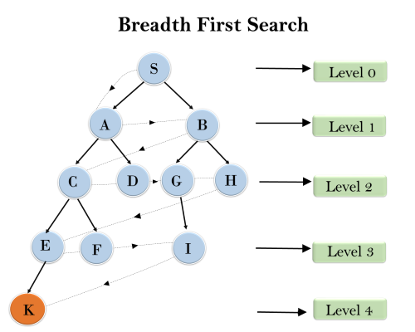

ii) Uniform-cost search
When all step costs are equal, breadth-first search is optimal because it always expands the shallowest unexpanded node. By a simple extension, we can find an algorithm that is optimal with any step-cost function. Instead of expanding the shallowest node, uniform-cost search expands the node n with the lowest path cost g(n). This is done by storing the frontier as a priority queue ordered by g.
It is easy to see that uniform-cost search is optimal in general. First, we observe that whenever uniform-cost search selects a node n for expansion, the optimal path to that node has been found.
Then, because step costs are nonnegative, paths never get shorter as nodes are added. These two facts together imply that uniform-cost search expands nodes in order of their optimal path cost. Hence, the first goal node selected for expansion must be the optimal solution.
Uniform-cost search is guided by path costs rather than depths, so its complexity is not easily characterized in terms of b and d. Instead, let C∗ be the cost of the optimal solution,7 and assume that every action costs at least . Then the algorithm’s worst-case time and space complexity is 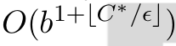 , which can be much greater than bd. This is because uniform cost search can explore large trees of small steps before exploring paths involving large and perhaps useful steps. When all step costs are equal,  is just b^{d+1}. When all step costs are the same, uniform-cost search is similar to breadth-first search, except that the latter stops as soon as it generates a goal, whereas uniform-cost search examines all the nodes at the goal’s depth to see if one has a lower cost; thus uniform-cost search does strictly more work by expanding nodes at depth d unnecessarily.
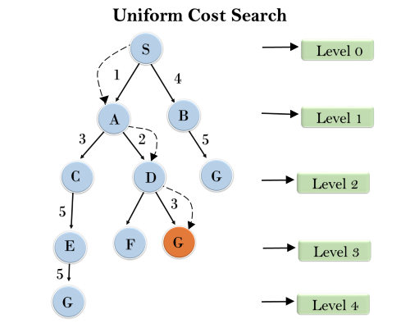
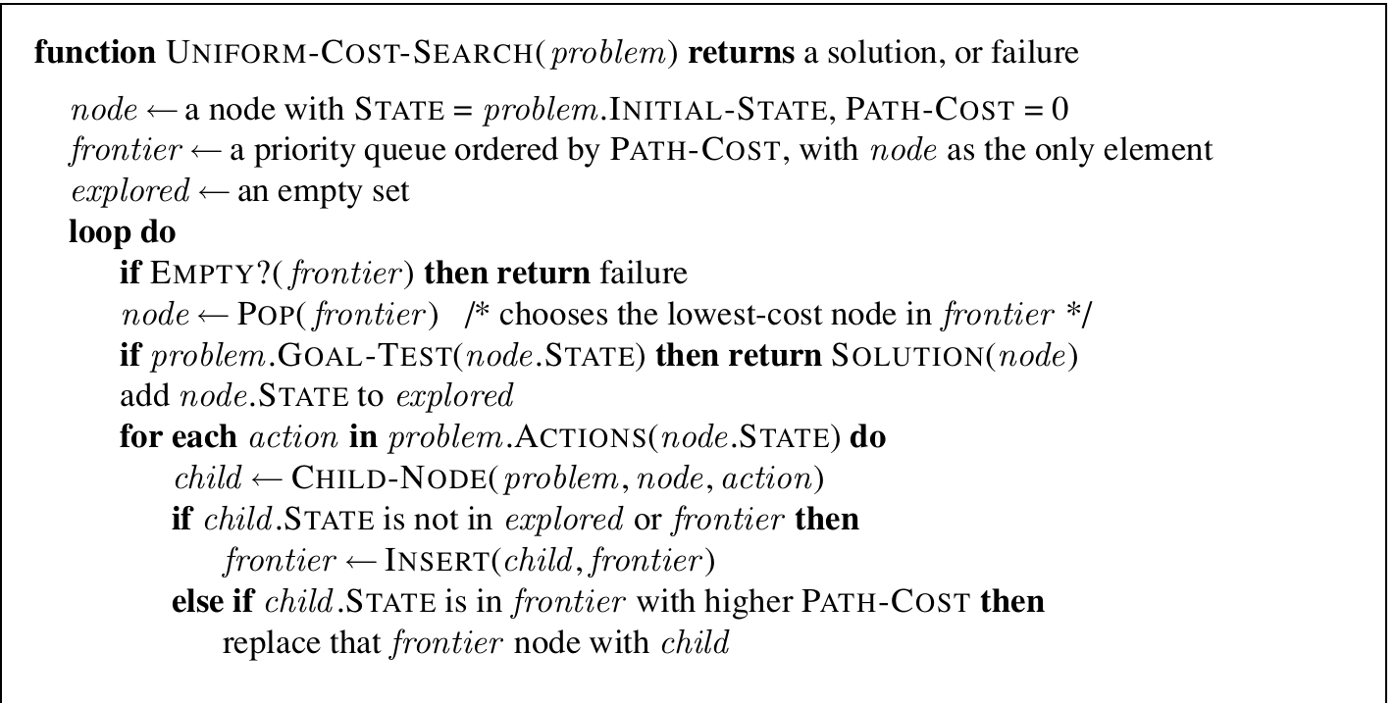
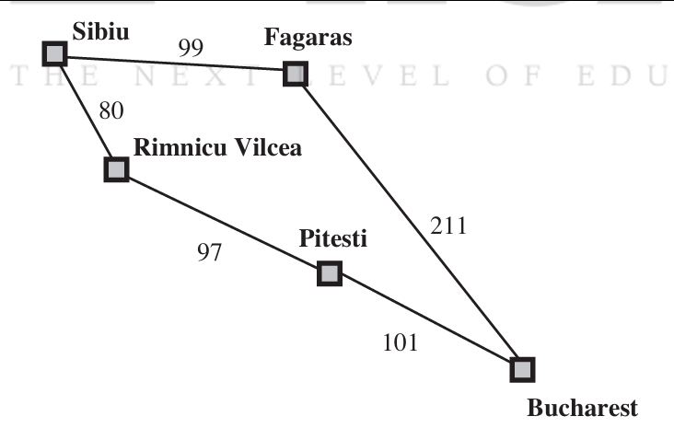

iii) Depth-first search
Depth-first search always expands the deepest node in the current frontier of the search tree.The search proceeds immediately to the deepest level of the search tree, where the nodes have no successors. As those nodes are expanded, they are dropped from the frontier, so then the search “backs up” to the next deepest node that still has unexplored successors.
breadth-first-search uses a FIFO queue, depth-first search uses a LIFOqueue. A LIFO queue means that the most recently generated node is chosen for expansion. This must be the deepest unexpanded node because it is one deeper than its parent—which, in turn, was the deepest unexpanded node when it was selected.
The time complexity of depth-first graph search is bounded by the size of the state space (which may be infinite, of course). A depth-first tree search, on the other hand, may generate all of the O(b^{m}) nodes in the search tree, where m is the maximum depth of any node; this can be much greater than the size of the state space.

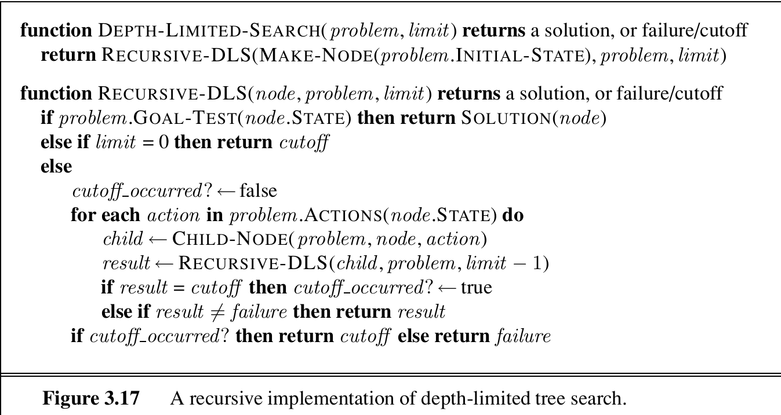

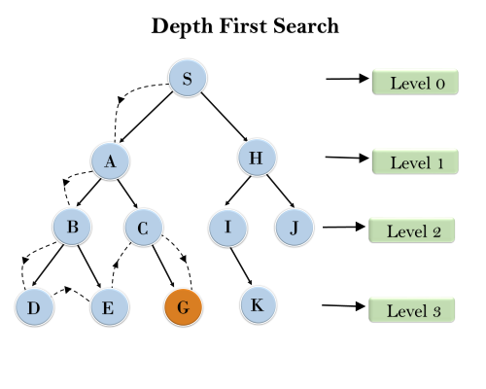

compares search strategies in terms of the four evaluation criteria
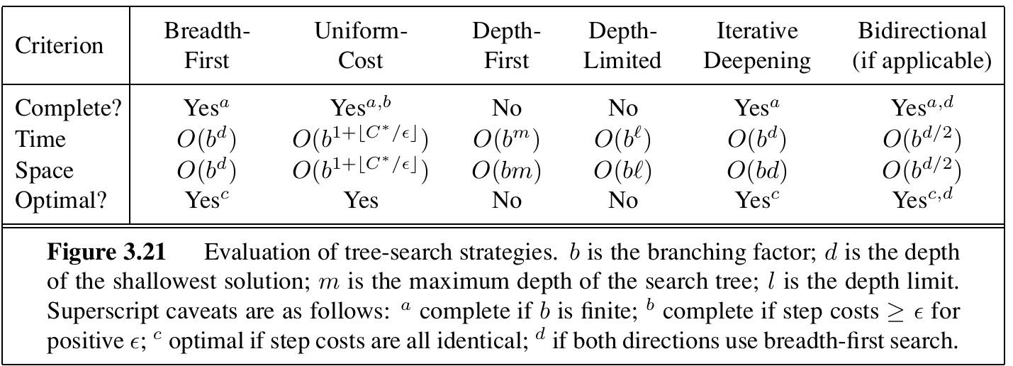

2.5 informed search strategies
The general approach we consider is called best-first search. Best-first search is an instance of the general TREE-SEARCH or GRAPH-SEARCH algorithm in which a node is selected for expansion based on an evaluation function, f(n). The evaluation function is construed as a cost estimate, so the node with the lowest evaluation is expanded first. The implementation of best-first graph search is identical to that for uniform-cost search , except for the use of f instead of g to order the priority queue.
The choice of f determines the search strategy. Most best-first algorithms include as a component of f a heuristic function, denoted h(n):
h(n)=estimated cost of the cheapest path from the state at node n to a goal state.
2.6 heuristic functions
A] Greedy best-first search
Greedy best-first search tries to expand the node that is closest to the goal, on the grounds that this is likely to lead to a solution quickly. Thus, it evaluates nodes by using just the heuristic function; that is, f(n)=h(n).
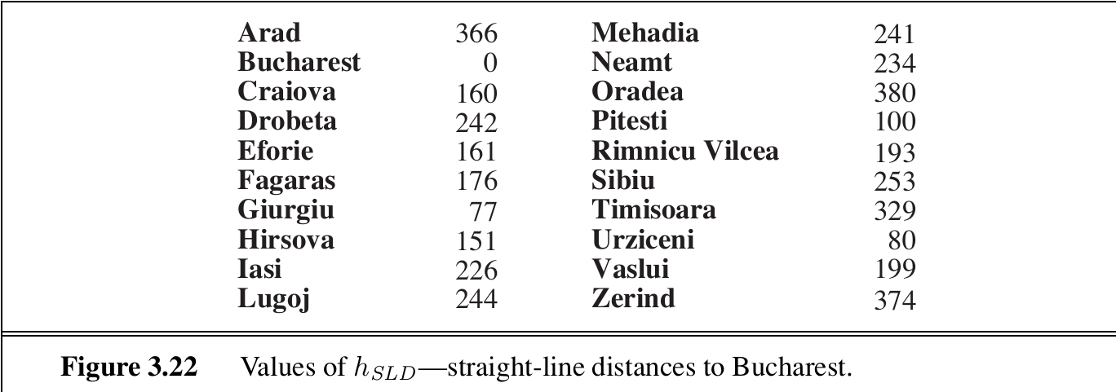
Let us see how this works for route-finding problems in Romania; we use the straight line distance heuristic, which we will call hSLD. If the goal is Bucharest, we need to know the straight-line distances to Bucharest. For example, hSLD(In(Arad))=366. Notice that the values of hSLD cannot be computed from the problem description itself. Moreover, it takes a certain amount of experience to know that hSLD is correlated with actual road distances and is, therefore, a useful heuristic.
The progress of a greedy best-first search using hSLD to find a path from Arad to Bucharest. The first node to be expanded from Arad will be Sibiu because it is closer to Bucharest than either Zerind or Timisoara. The next node to be expanded will be Fagaras because it is closest. Fagaras in turn generates Bucharest, which is the goal. For this particular problem, greedy best-first search using hSLD finds a solution without ever expanding a node that is not on the solution path; hence, its search cost is minimal. It is not optimal, however: the path via Sibiu and Fagaras to Bucharest is 32 kilometres longer than the path through Rimnicu Vilcea and Pitesti. This shows why the algorithm is called “greedy”—at each step it tries to get as close to the goal as it can.
Greedy best-first tree search is also incomplete even in a finite state space, much like depth-first search. Consider the problem of getting from Iasi to Fagaras. The heuristic suggests that Neamt be expanded first because it is closest to Fagaras, but it is a dead end. The solution is to go first to Vaslui—a step that is actually farther from the goal according to the heuristic—and then to continue to Urziceni, Bucharest, and Fagaras.The algorithm will never find this solution, however, because expanding Neamt puts Iasi back into the frontier, Iasi is closer to Fagaras than Vasluiis, and so Iasi will be expanded again, leading to an infinite loop. (The graph search version is complete infinite spaces, but not in infinite ones.)The worst-case time and space complexity for the tree version is O(bm), where m is the maximum depth of the search space. With a good heuristic function, however, the complexity can be reduced substantially. The amount of the reduction depends on the particular problem and on the quality of the heuristic.

B] A* search: Minimizing the total estimated solution cost:
The most widely known form of best-first search is called A∗ search (pronounced “A-star search”). It evaluates nodes by combining g(n), the cost to reach the node, and h(n), the cost to get from the node to the goal:
f(n)=g(n)+h(n)
Since g(n) gives the path cost from the start node to node n, and h(n) is the estimated cost of the cheapest path from n to the goal, we have
f(n)=estimated cost of the cheapest solution through n.
Thus, if we are trying to find the cheapest solution, a reasonable thing to try first is the node with the lowest value of g(n)+h(n). It turns out that this strategy is more than just reasonable: provided that the heuristic function h(n) satisfies certain conditions, A∗ search is both complete and optimal. The algorithm is identical to UNIFORM-COST-SEARCH except that A∗ uses g+h instead of g.
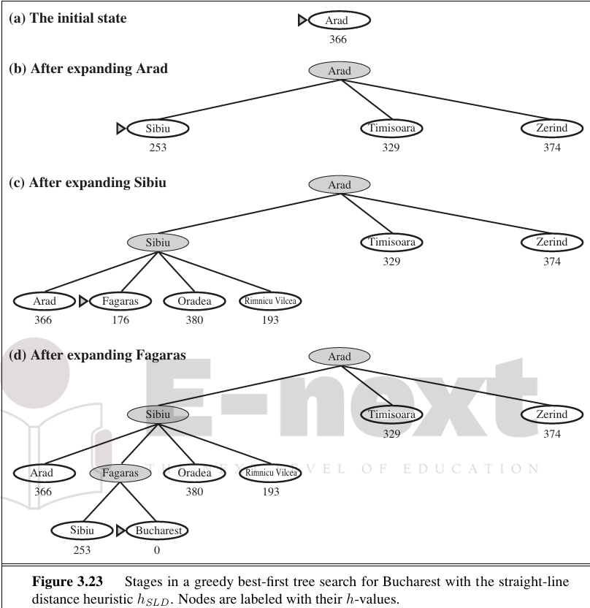
Conditions for optimality: Admissibility and consistency
The first condition we require for optimality is that h(n) be an admissible heuristic. An admissible heuristic is one that never overestimates the cost to reach the goal. Because g(n) is the actual cost to reach n along the current path, and f(n)=g(n)+h(n),we have as an immediate consequence that f(n) never overestimates the true cost of a solution along the current path through n.
Admissible heuristics are by nature optimistic because they think the cost of solving the problem is less than it actually is. An obvious example of an admissible heuristic is the straight-line distance hSLD that we used in getting to Bucharest. Straight-line distance is admissible because the shortest path between any two points is a straight line, so the straight line cannot be an overestimate.
A second, slightly stronger condition called consistency (or sometimes monotonicity) is required only for applications of A∗ to graph search. A heuristic h(n) is consistent if, for every node n and every successor n’ of n generated by any action a, the estimated cost of reaching the goal from n is no greater than the step cost of getting to n’ plus the estimated cost of reaching the goal from n’:
h(n) ≤ c(n,a,n’)+h(n’)
This is a form of the general triangle inequality, which stipulates that each side of a triangle cannot be longer than the sum of the other two sides. Here, the triangle is formed by n, n’, and the goal Gn closest to n. For an admissible heuristic, the inequality makes perfect sense: if there were a route from n to Gn via n’ that was cheaper than h(n), that would violate the property that h(n) is a lower bound on the cost to reach Gn.
Optimality of A*
A∗ has the following properties: the tree-search version of A∗ is optimal if h(n) is admissible, while the graph-search version is optimal if h(n) is consistent.
The first step is to establish the following: if h(n) is consistent, then the values of f(n) along any path are nondecreasing. The proof follows directly from the definition of consistency. Suppose n is a successor of n; then g(n’)=g(n)+c(n,a,n’) for some action a, and we have
f(n’)=g(n’)+h(n’)=g(n)+c(n,a,n’)+h(n’) ≥ g(n)+h(n)=f(n)
The next step is to prove that whenever A∗ selects a node n for expansion, the optimal path to that node has been found. Were this not the case, there would have to be another frontier node n’ on the optimal path from the start node to n.
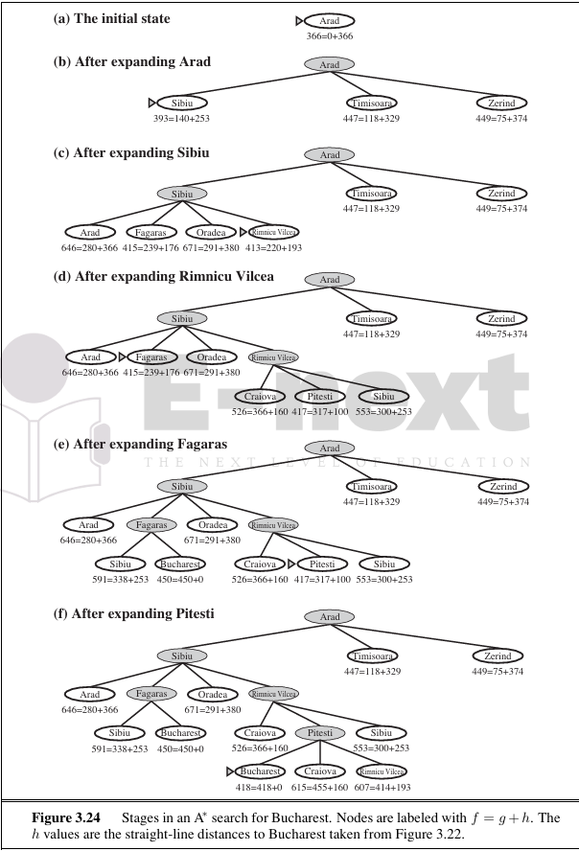
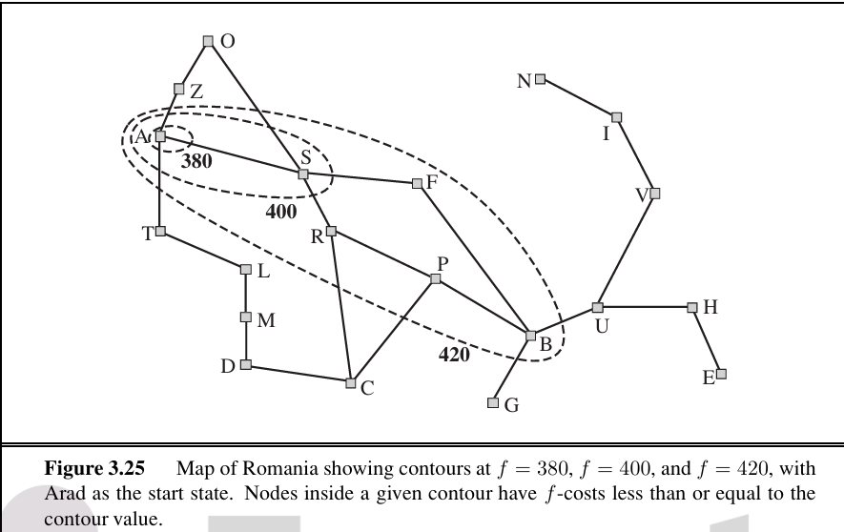

2.7 local search algorithms
If the path to the goal does not matter, we might consider a different class of algorithms, ones that do not worry about paths at all. Local search algorithms operate using a single current node (rather than multiple paths) and generally move only to neighbors of that node. Typically, the paths followed by the search are not retained. Although local search algorithms are not systematic, they have two key advantages: (1) they use very little memory—usually a constant amount; and (2) they can often find reasonable solutions in large or infinite (continuous) state spaces for which systematic algorithms are unsuitable.
To understand local search, we find it useful to consider the state-space landscape. A landscape has both “location” (defined by the state) and “elevation” (defined by the value of the heuristic cost function or objective function). If elevation corresponds to cost, then the aim is to find the lowest valley—a global minimum; if elevation corresponds to an objective function, then the aim is to find the highest peak—a global maximum. (You can convert from one to the other just by inserting a minus sign.) Local search algorithms explore this landscape. A complete local search algorithm always finds a goal if one exists; an optimal algorithm always finds a global minimum/maximum.
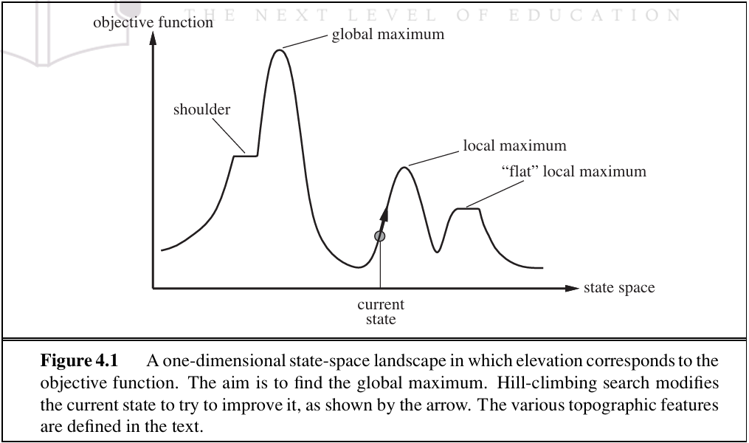
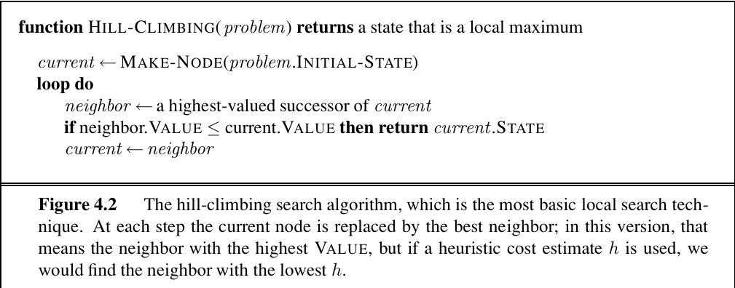
hill-climbing search algorithm
The hill-climbing search algorithm (steepest-ascent version) is shown in Figure 4.2. It is simply a loop that continually moves in the direction of increasing value—that is, uphill. It terminates when it reaches a “peak” where no neighbor has a higher value. The algorithm does not maintain a search tree, so the data structure for the current node need only record the state and the value of the objective function. Hill climbing does not look ahead beyond the immediate neighbors of the current state. This resembles trying to find the top of Mount Everest in a thick fog while suffering from amnesia.
Local search algorithms typically use a complete-state formulation, where each state has 8 queens on the board, one per column. The successors of a state are all possible states generated by moving a single queen to another square in the same column (so each state has 8×7=56successors). The heuristic cost function h is the number of pairs of queens that are attacking each other, either directly or indirectly. The global minimum of this function is zero, which occurs only at perfect solutions. Figure 4.3(a) shows a state with h=17.
The figure also shows the values of all its successors, with the best successors having h=12. Hill-climbing algorithms typically choose randomly among the set of best successors if there is more than one.
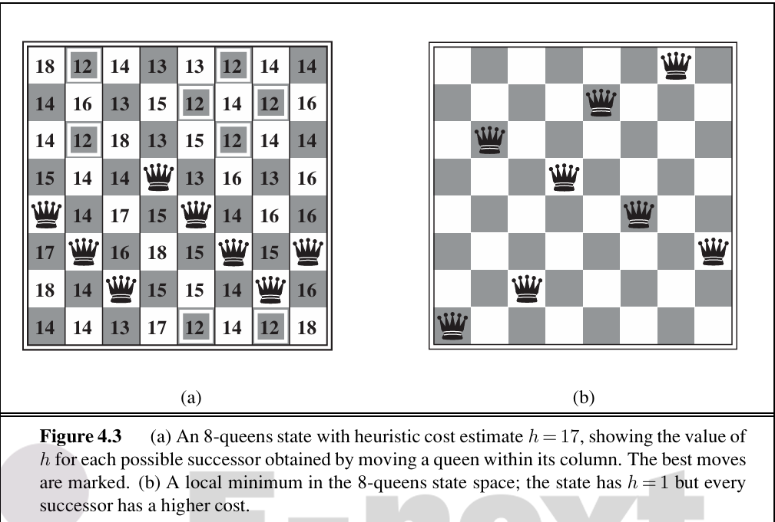
Hill climbing is sometimes called greedy local search because it grabs a good neighbour state without thinking ahead about where to go next. Although greed is considered one of the seven deadly sins, it turns out that greedy algorithms often perform quite well. Hill climbing often makes rapid progress toward a solution because it is usually quite easy to improve a bad state. For example, from the state in Figure 4.3(a), it takes just five steps to reach the state in Figure 4.3(b), which has h=1and is very nearly a solution. Unfortunately, hill climbing often gets stuck for the following reasons:
Local maxima: a local maximum is a peak that is higher than each of its neighbouring states but lower than the global maximum. Hill-climbing algorithms that reach the vicinity of a local maximum will be drawn upward toward the peak but will then be stuck with nowhere else to go. Figure 4.1 illustrates the problem schematically. More concretely, the state in Figure 4.3(b) is a local maximum (i.e., a local minimum for the cost h); every move of a single queen makes the situation worse.
• Ridges: a ridge is shown in Figure 4.4. Ridges result in a sequence of local maxima that is very difficult for greedy algorithms to navigate.
• Plateaux: a plateau is a flat area of the state-space landscape. It can be a flat local maximum, from which no uphill exit exists, or a shoulder, from which progress is possible. (See Figure 4.1.) A hill-climbing search might get lost on the plateau.

Simulated annealing
A hill-climbing algorithm that never makes “downhill” moves toward states with lower value (or higher cost) is guaranteed to be incomplete, because it can get stuck on a local maximum. In contrast, a purely random walk—that is, moving to a successor chosen uniformly at random from the set of successors—is complete but extremely inefficient. Therefore, it seems reasonable to try to combine hill climbing with a random walk in some way that yields both efficiency and completeness. Simulated annealing is such an algorithm. In metallurgy, annealing is the process used to temper or harden metals and glass by heating them to a high temperature and then gradually cooling them, thus allowing the material to reach a low energy crystalline state. To explain simulated annealing, we switch our point of view from hill climbing to gradient descent (i.e., minimizing cost) and imagine the task of getting a ping-pong ball into the deepest crevice in a bumpy surface. If we just let the ball roll, it will come to rest at a local minimum. If we shake the surface, we can bounce the ball out of the local minimum. The trick is to shake just hard enough to bounce the ball out of local minima but not hard enough to dislodge it from the global minimum. The simulated-annealing solution is to start by shaking hard (i.e., at a high temperature) and then gradually reduce the intensity of the shaking (i.e., lower the temperature).

2.8 Searching with non-deterministic action
When the environment is either partially observable or nondeterministic (or both), percepts become useful. In a partially observable environment, every percept helps narrow down the set of possible states the agent might be in, thus making it easier for the agent to achieve its goals. When the environment is nondeterministic, percepts tell the agent which of the possible outcomes of its actions has actually occurred. In both cases, the future percepts cannot be determined in advance and the agent’s future actions will depend on those future percepts. So, the solution to a problem is not a sequence but a contingency plan (also known as a strategy) that specifies what to do depending on what percepts are received.

The erratic vacuum world
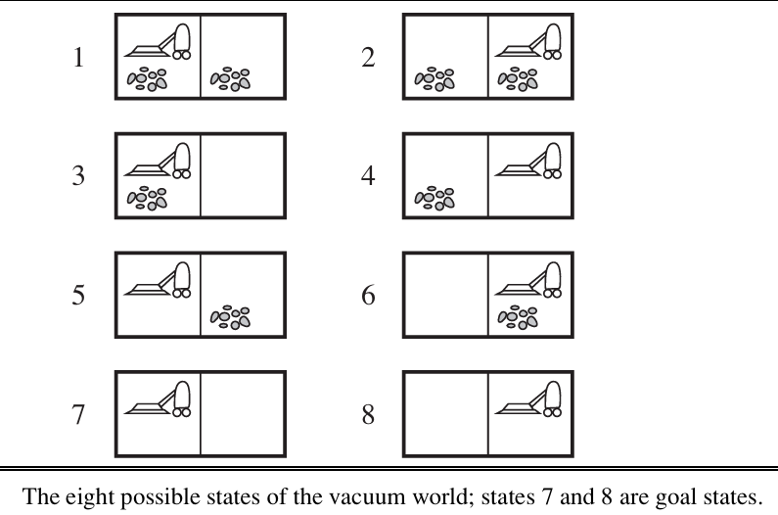

Now suppose that we introduce nondeterminism in the form of a powerful but erratic vacuum cleaner. In the erratic vacuum world,theSuck action works as follows:
• When applied to a dirty square the action cleans the square and sometimes cleans up dirt in an adjacent square, too.
• When applied to a clean square the action sometimes deposits dirt on the carpet.
To provide a precise formulation of this problem, we need to generalize the notion of a transition model. Instead of defining the transition model by a RESULT function that returns a single state, we use a RESULTS function that returns a set of possible outcome states. For example, in the erratic vacuum world, the Suck action in state 1 leads to a state in the set {5,7}—the dirt in the right-hand square may or may not be vacuumed up.
We also need to generalize the notion of a solution to the problem. For example, if we start in state 1, there is no single sequence of actions that solves the problem. Instead, we need a contingency plan such as the following:
[Suck, if State =5 then [Right,Suck] else []].
Thus, solutions for nondeterministic problems can contain nested if–then–else statements; this means that they are trees rather than sequences. This allows the selection of actions based on contingencies arising during execution. Many problems in the real, physical world are contingency problems because exact prediction is impossible. For this reason, many people keep their eyes open while walking around or driving.
AND–OR search trees
In a deterministic environment, the only branching is introduced by the agent’s own choices in each state. We call these nodes OR nodes. In the vacuum world, for example, at an OR node the agent chooses Left or Right or Suck. In a nondeterministic environment, branching is also introduced by the environment’s choice of outcome for each action. We call these nodes AND nodes. For example, the Suck action in state 1 leads to a state in the set {5,7}, so the agent would need to find a plan for state 5 and for state 7. These two kinds of nodes alternate, leading to an AND–OR tree.
A solution for an AND–OR search problem is a subtree that (1) has a goal node at every leaf, (2) specifies one action at each of its OR nodes, and (3) includes every outcome branch at each of its AND nodes.
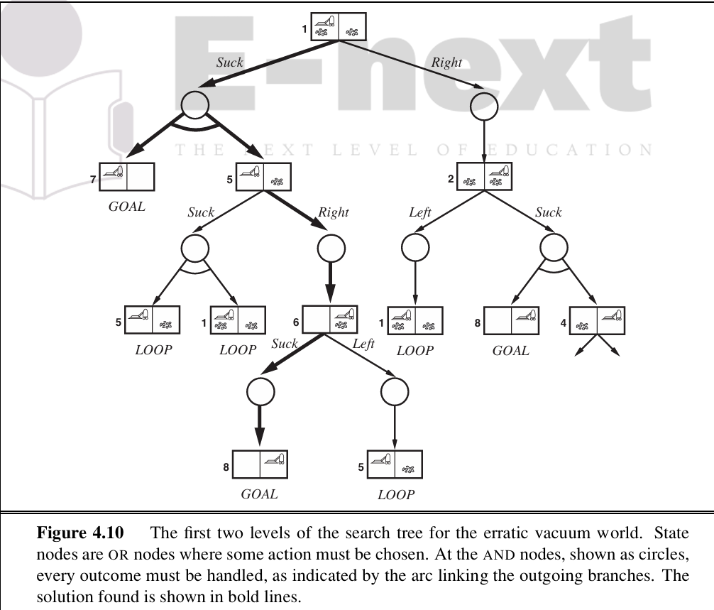
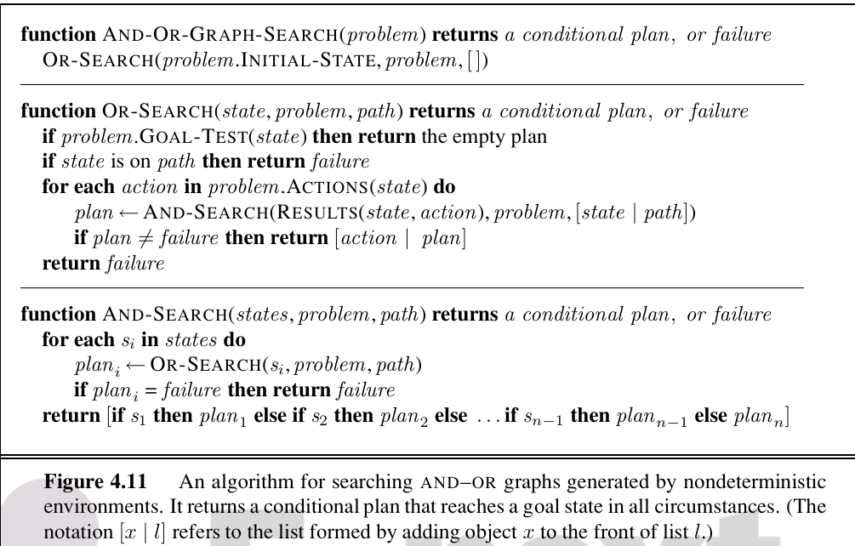
AND–OR graphs can also be explored by breadth-first or best-first methods. The concept of a heuristic function must be modified to estimate the cost of a contingent solution rather than a sequence, but the notion of admissibility carries over and there is an analog of the A∗ algorithm for finding optimal solutions.
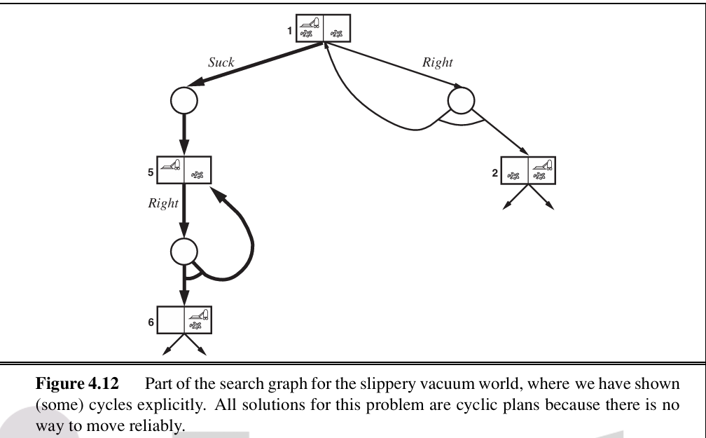

2.9 searching with partial observations
The key concept required for solving partially observable problems is the belief state, representing the agent’s current belief about the possible physical states it might be in, given the sequence of actions and percepts up to that point. We begin with the simplest scenario for studying belief states, which is when the agent has no sensors at all; then we add in partial sensing as well as nondeterministic actions.
When the agent’s percepts provide no information at all, we have what is called a sensor less problem or sometimes a conformant problem. At first, one might think the sensorless agent has no hope of solving a problem if it has no idea what state it’s in; in fact, sensorless problems are quite often solvable. Moreover, sensorless agents can be surprisingly useful, primarily because they don’t rely on sensors working properly. In manufacturing systems, for example, many ingenious methods have been developed for orienting parts correctly from an unknown initial position by using a sequence of actions with no sensing at all. The high cost of sensing is another reason to avoid it: for example, doctors often prescribe a broad spectrum antibiotic rather than using the contingent plan of doing an expensive blood test, then waiting for the results to come back, and then prescribing a more specific antibiotic and perhaps hospitalization because the infection has progressed too far.
We can make a sensorless version of the vacuum world. Assume that the agent knows the geography of its world, but doesn’t know its location or the distribution of dirt. In that case, its initial state could be any element of the set {1,2,3,4,5,6,7,8}. Now, consider what happens if it tries the action Right. This will cause it to be in one of the states {2,4,6,8}—the agent now has more information! Furthermore, the action sequence [Right,Suck] will always end up in one of the states {4,8}. Finally, the sequence [Right,Suck,Left,Suck] is guaranteed to reach the goal state 7 no matter what the start state. We say that the agent can coerce the world into state7.
It is instructive to see how the belief-state search problem is constructed. Suppose the underlying physical problem P is defined by ACTIONSP,RESULTP,GOAL-TESTP,and STEP-COSTP. Then we can define the corresponding sensorless problem as follows:
• Belief states: The entire belief-state space contains every possible set of physical states. If P has N states, then the sensorless problem has up to 2N states, although many may be unreachable from the initial state.
• Initial state: Typically the set of all states in P, although in some cases the agent will have more knowledge than this.
• Actions: This is slightly tricky. Suppose the agent is in belief state b={s1,s2},but ACTIONSP(s1)= ACTIONSP(s2); then the agent is unsure of which actions are legal. If we assume that illegal actions have no effect on the environment, then it is safe to take the union of all the actions in any of the physical states in the current belief state b.
Transition model: The agent doesn’t know which state in the belief state is the right one; so as far as it knows, it might get to any of the states resulting from applying the action to one of the physical states in the belief state.
• Goal test: The agent wants a plan that is sure to work, which means that a belief state satisfies the goal only if all the physical states in it satisfy GOAL-TESTP. The agent may accidentally achieve the goal earlier, but it won’t know that it has done so.
• Path cost: This is also tricky. If the same action can have different costs in different states, then the cost of taking an action in a given belief state could be one of several values.
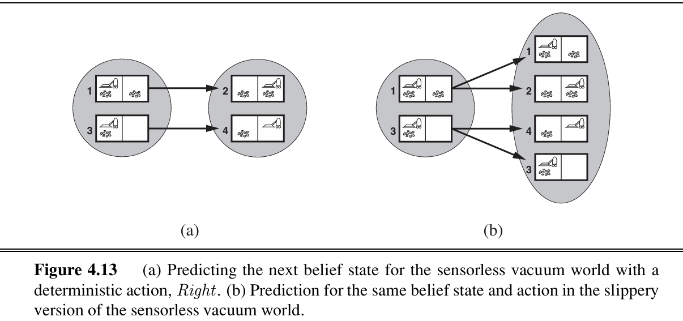
Even with this improvement, however, sensorless problem-solving as we have described it is seldom feasible in practice. The difficulty is not so much the vastness of the belief-state space—even though it is exponentially larger than the underlying physical state space; in most cases the branching factor and solution length in the belief-state space and physical state space are not so different. The real difficulty lies with the size of each belief state. For example, the initial belief state for the 10×10 vacuum world contains 100×2¹⁰⁰ or around 10³² physical states—far too many if we use the atomic representation, which is an explicit list of states.
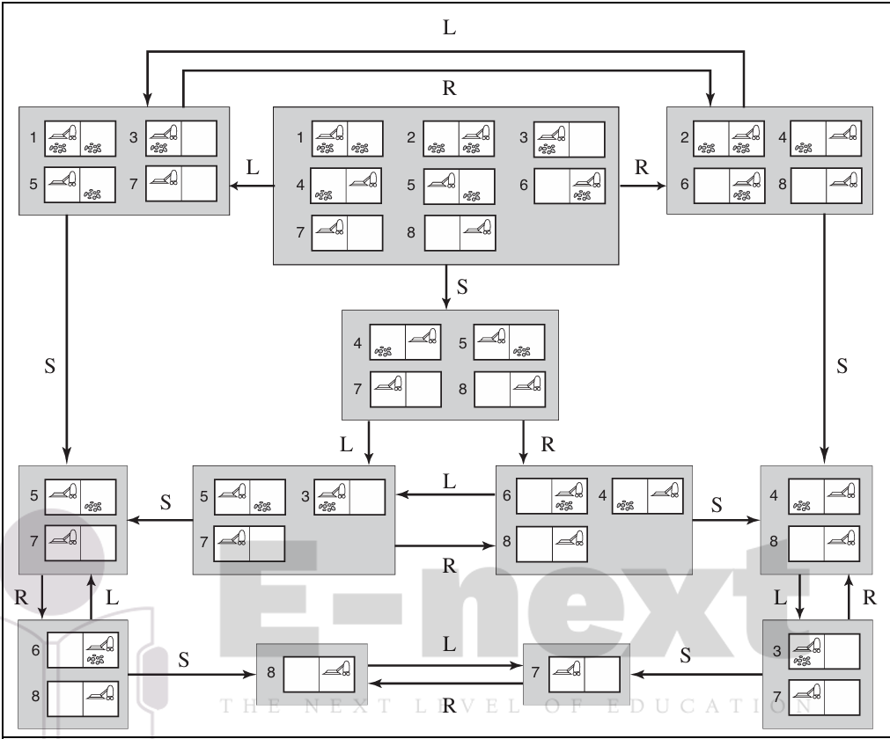
One solution is to represent the belief state by some more compact description. In English, we could say the agent knows “Nothing” in the initial state; after moving Left, we could say, “Not in the rightmost column,” and so on. Another approach is to avoid the standard search algorithms, which treat belief states as black boxes just like any other problem state. Instead, we can look inside the belief states and develop incremental belief-state search algorithms that build up the solution one physical state at a time. For example, in the sensorless vacuum world, the initial belief state is {1,2,3,4,5,6,7, 8}, and we have to find an action sequence that works in all 8 states. We can do this by first finding a solution that works for state 1; then we check if it works for state 2; if not, go back and find a different solution for state 1, and so on. Just as an AND–OR search has to find a solution for every branch at an AND node, this algorithm has to find a solution for every state in the belief state; the difference is that AND–OR search can find a different solution for each branch, whereas an incremental belief-state search has to find one solution that works for all the states.
The main advantage of the incremental approach is that it is typically able to detect failure quickly—when a belief state is unsolvable, it is usually the case that a small subset of the belief state, consisting of the first few states examined, is also unsolvable. In some cases, this leads to a speedup proportional to the size of the belief states, which may themselves be as large as the physical state space itself.
Even the most efficient solution algorithm is not of much use when no solutions exist. Many things just cannot be done without sensing. For example, the sensorless 8-puzzle is impossible. On the other hand, a little bit of sensing can go a long way. For example, every 8-puzzle instance is solvable if just one square is visible—the solution involves moving each tile in turn into the visible square and then keeping track of its location.
Searching with observations
For a general partially observable problem, we have to specify how the environment generates percepts for the agent. For example, we might define the local-sensing vacuum world to be one in which the agent has a position sensor and a local dirt sensor but has no sensor capable of detecting dirt in other squares. The formal problem specification includes a PERCEPT(s) function that returns the percept received in a given state. (If sensing is nondeterministic, then we use a PERCEPTS function that returns a set of possible percepts.) For example, in the local-sensing vacuum world, the PERCEPT in state 1 is [A,Dirty]. Fully observable problems are a special case in which PERCEPT(s)=s for every state s, while sensorless problems are a special case in which PERCEPT(s)=null.
The prediction stage is the same as for sensorless problems: given the action a in belief state b, the predicted belief state is ˆ b= PREDICT(b,a).
The observation prediction stage determines the set of percepts o that could be ob served in the predicted belief state
2.10 online search agents and unknown environments
Online search is a necessary idea for unknown environments, where the agent does not know what states exist or what its actions do. In this state of ignorance, the agent faces an exploration problem and must use its actions as experiments in order to learn enough to make deliberation worthwhile.
online search problem
An online search problem must be solved by an agent executing actions, rather than by pure computation. We assume a deterministic and fully observable environment (Chapter 17 re laxes these assumptions), but we stipulate that the agent knows only the following:
• ACTIONS(s), which returns a list of actions allowed in state s;
• The step-cost function c(s,a,s)—note that this cannot be used until the agent knows that s is the outcome; and
• GOAL-TEST(s).
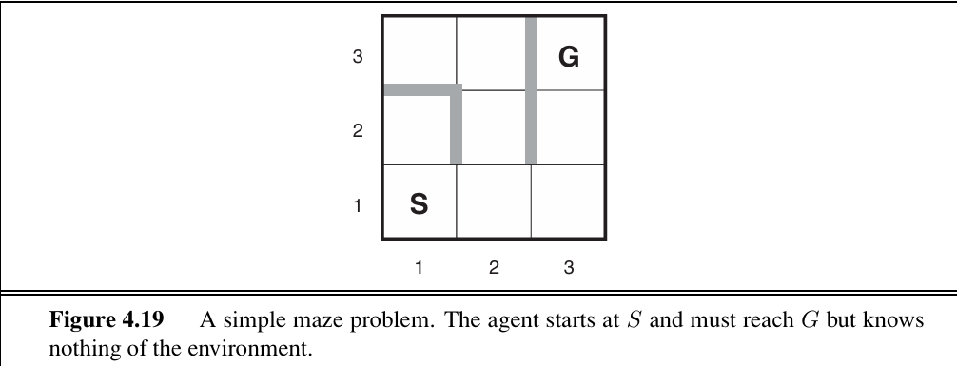
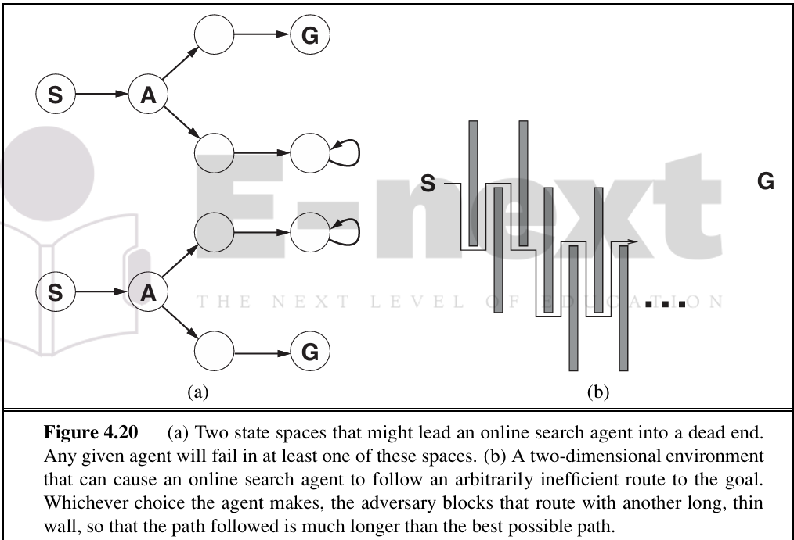
Finally, the agent might have access to an admissible heuristic function h(s) that es timates the distance from the current state to a goal state. For example, in Figure 4.19, the agent might know the location of the goal and be able to use the Manhattan-distance heuristic.
Typically, the agent’s objective is to reach a goal state while minimizing cost. (Another possible objective is simply to explore the entire environment.) The cost is the total path cost of the path that the agent actually travels. It is common to compare this cost with the path cost of the path the agent would follow if it knew the search space in advance—that is, the actual shortest path (or shortest complete exploration). In the language of online algorithms, this is called the competitive ratio; we would like it to be as small as possible.
Although this sounds like a reasonable request, it is easy to see that the best achievable competitive ratio is infinite in some cases. For example, if some actions are irreversible— i.e., they lead to a state from which no action leads back to the previous state—the online search might accidentally reach a dead-end state from which no goal state is reachable. Per haps the term “accidentally” is unconvincing—after all, there might be an algorithm that happens not to take the dead-end path as it explores. Our claim, to be more precise, is that no algorithm can avoid dead ends in all state spaces. To an online search algorithm that has visited states S and A, the two state spaces look identical, so it must make the same decision in both. Therefore, it will fail in one of them. This is an example of an adversary argument—we can imagine an adversary constructing the state space while the agent explores it and putting the goals and dead ends wherever it chooses.
Dead ends are a real difficulty for robot exploration—staircases, ramps, cliffs, one-way streets, and all kinds of natural terrain present opportunities for irreversible actions. To make progress, we simply assume that the state space is safely explorable—that is, some goal state is reachable from every reachable state. State spaces with reversible actions, such as mazes and 8-puzzles, can be viewed as undirected graphs and are clearly safely explorable.

online agent
After each action, an online agent receives a percept telling it what state it has reached; from this information, it can augment its map of the environment. The current map is used to decide where to go next. This interleaving of planning and action means that online search algorithms are quite different from the offline search algorithms we have seen previously. For example, offline algorithms such as A∗ can expand a node in one part of the space and then immediately expand a node in another part of the space, because node expansion involves simulated rather than real actions. An online algorithm, on the other hand, can discover successors only for a node that it physically occupies. To avoid traveling all the way across the tree to expand the next node, it seems better to expand nodes in a local order. Depth-first search has exactly this property because (except when backtracking) the next node expanded is a child of the previous node expanded.

Online local search
Like depth-first search, hill-climbing search has the property of locality in its node expansions. In fact, because it keeps just one current state in memory, hill-climbing search is already an online search algorithm! Unfortunately, it is not very useful in its simplest form because it leaves the agent sitting at local maxima with nowhere to go. Moreover, random restarts cannot be used, because the agent cannot transport itself to a new state.

Assignment Question
1.Explain Goal and problem formulation.
2 Explain Search, Solution and Execution w.r.t. AI.
3 Explain following terms: 1. State space of problem 2. Path in state space 3. Goal test 4. Path cost 5. Solution to problem
4.Explain 8-puzzle game problem.
5 Explain real world problem.
6 Explain Infrastructure for search algorithms.
7 Explain how algorithm’s performance can be evaluated?
8 What is meant by Uninformed Search and Uniform-cost search Explain in detail.
9 Explain different components of problem.
10 Explain BFS and DFS algorithm w.r.t. AI
11 What is meant by complexities? Explain it w.r.t. following algorithms. 1. BFS 2. DFS 3. Bidirectional 4. Uniform Cost 5. Interactive Deepning
12.Explain Hill Climbing search algorithm.
13 what is meant by Informed (Heuristic) Search Strategies.
14 Explain travelling Salesmen algorithm.
15 Compare different types of uninformed search strategies.
16 Write a short note on A* Search.
17 Explain local search algorithm
18 Explain greedy local search algorithm
19 Explain8-Queens state algorithm.
20 Explain Stochastic hill climbing search algorithm.
21 Explain searching with following. 1. Searching with nondeterministic actions 2. Searching with no observation 3. Searching with partial observations
22 What is meant by Contingency Plan? Explain
23 What is meant by genetic algorithm? Explain
24 What is meant by belief state? Explain Prediction stage of vaccum world.
25 Explain working of problem-solving agent for partially observable environments
26 What is meant by online search agents and unknown environment? Explain
27 Write an algorithm for online DFS agent searching.

